**Cloud –**

1. **Ec2-**

**Step 1-Create an AWS account for making an instance and then search Ec2 on dashboard and click to open-**

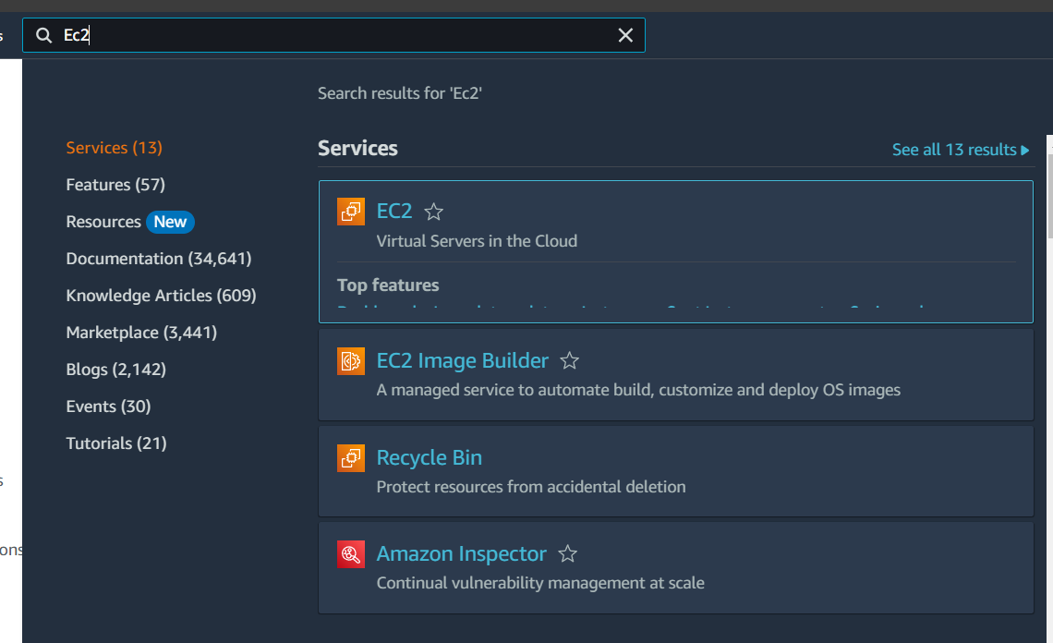



**Step 2- Click on launch instance to open it-**

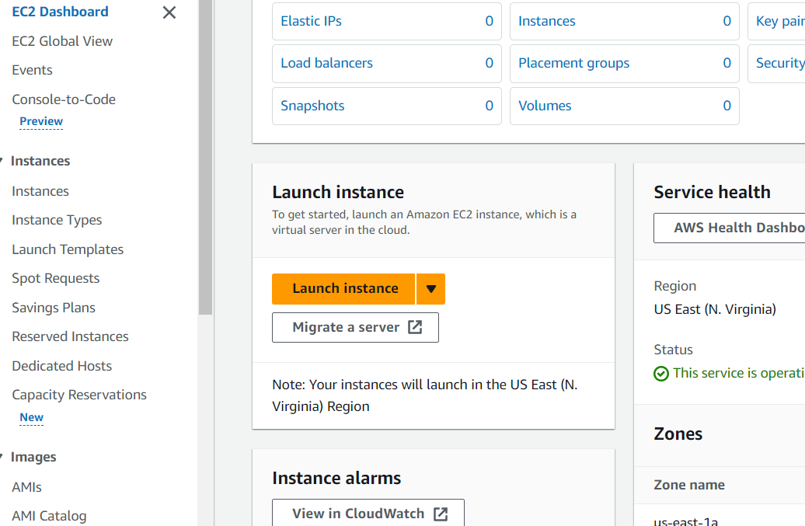



**Step 3- Launch an instance and add name,tags-** Give a name to instance as cdac12

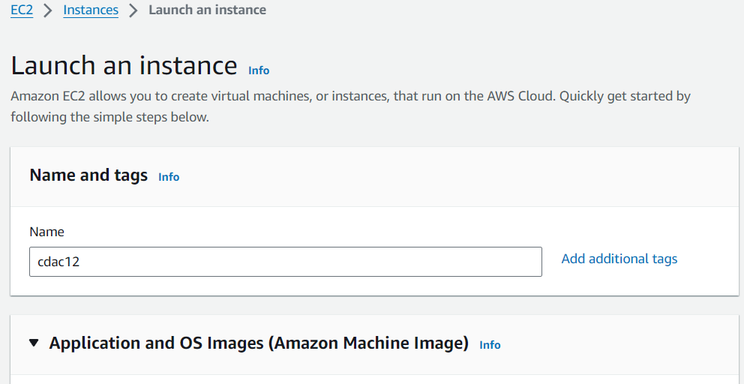



**Step 4- And allow all the given https/ssh forms-**

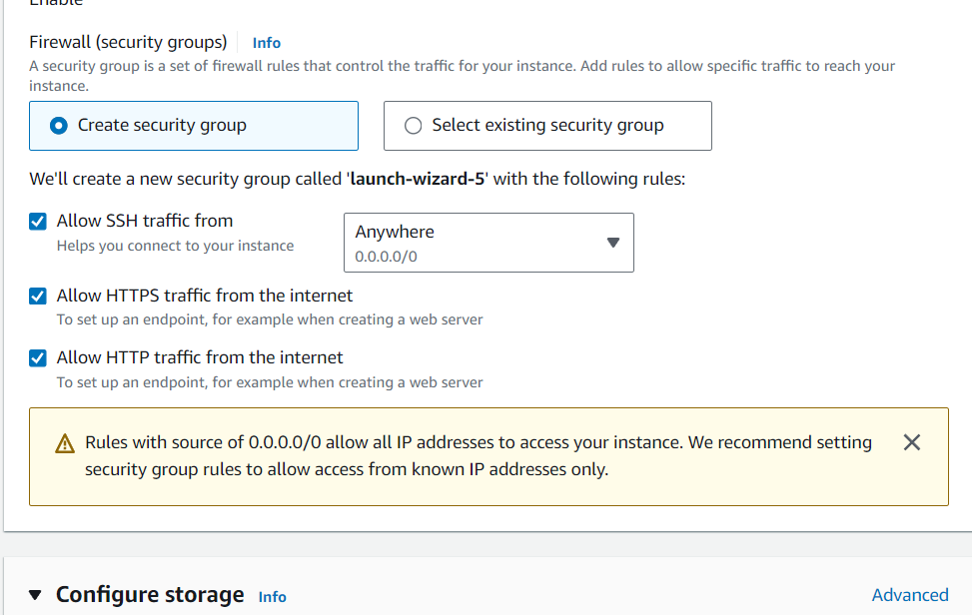



**Step-5- Create key pair using .ppk file format and then click on create kry pair-** After creating key pair this key pair add in files .

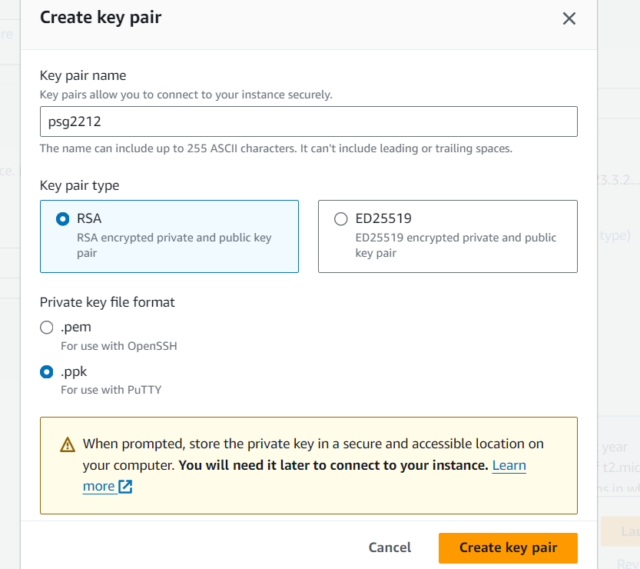



**Step 6- Click on launch instance and do a further process-**



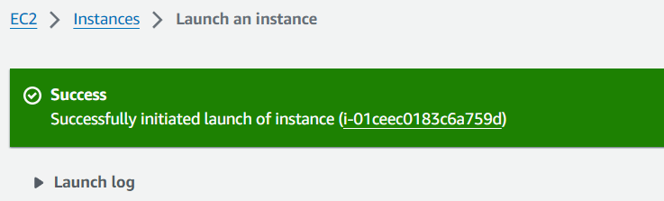

**Step 7- Here the created instance will be visible on screen -**

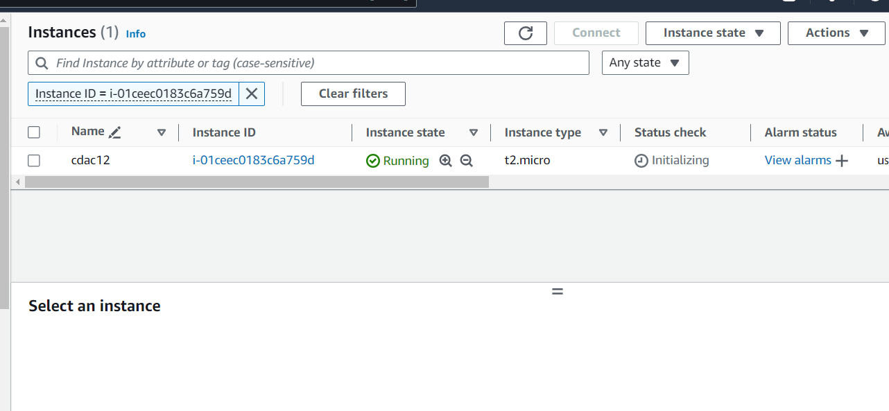



**Step 8- Click on created instance and then copied that created public IPV4 address-**

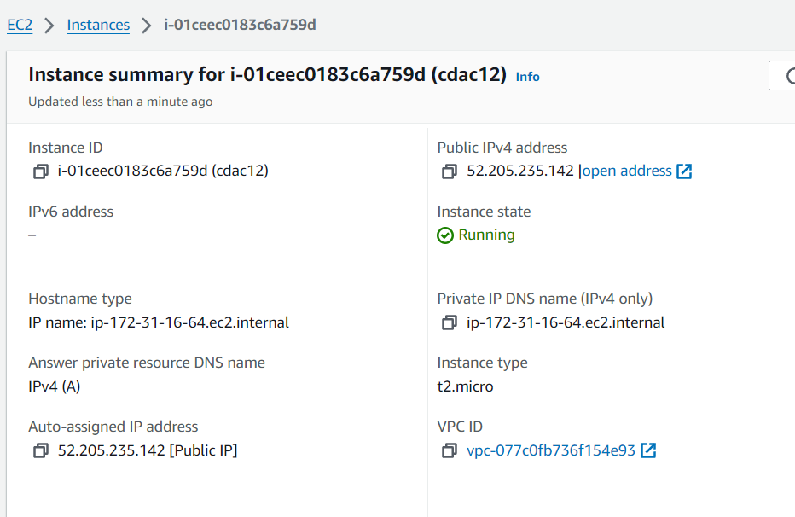



**Step 9- Open a putty and write a hostname with ip add-**

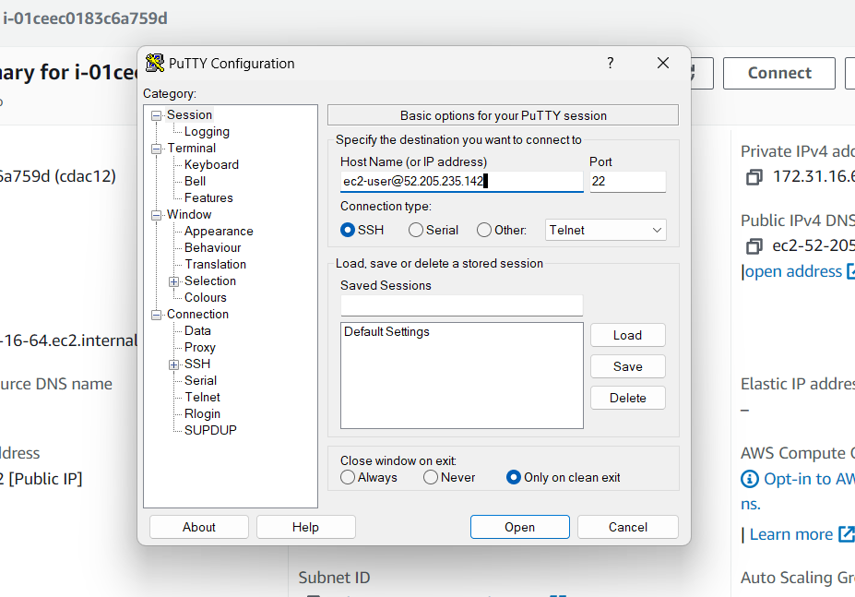



**Step -10- Using SSH path add the created .ppk file in it- (ssh->auth->credentials)**

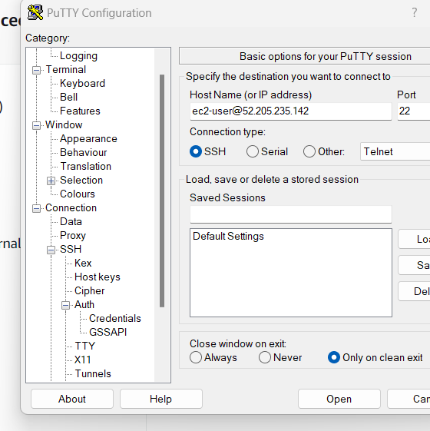



**Step 11- Here add created .ppk file and click on open-**

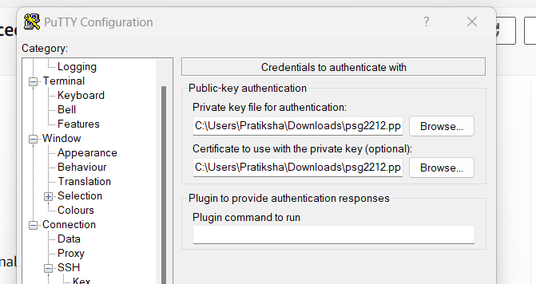



**Step 12- Authentication accept with public key-**

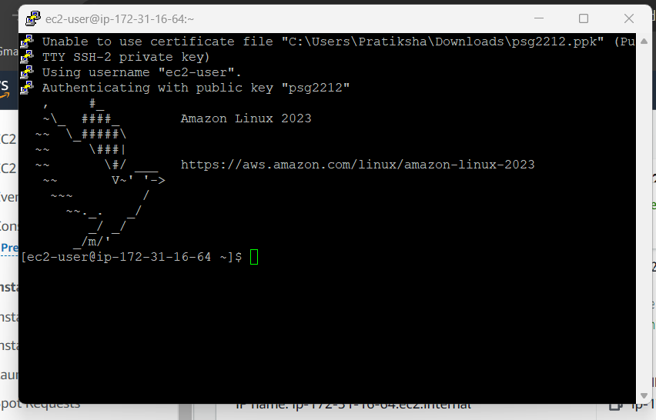

**Step 13- Go in root using (sudo -i) and then update -**

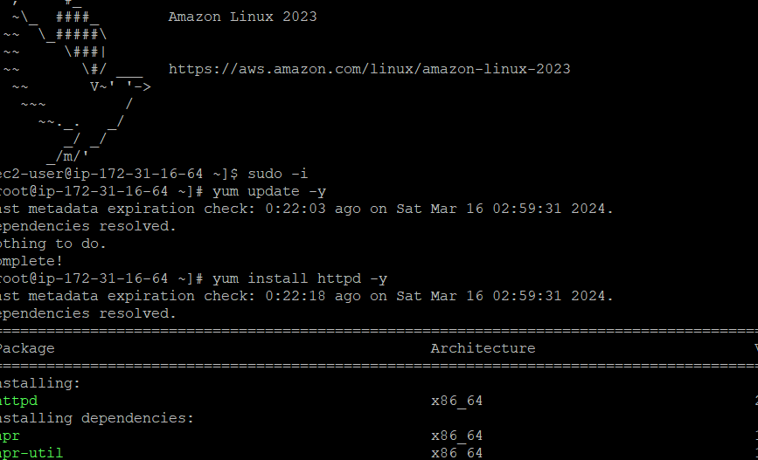



**Step 14- Start the system and see the status and enable it -**

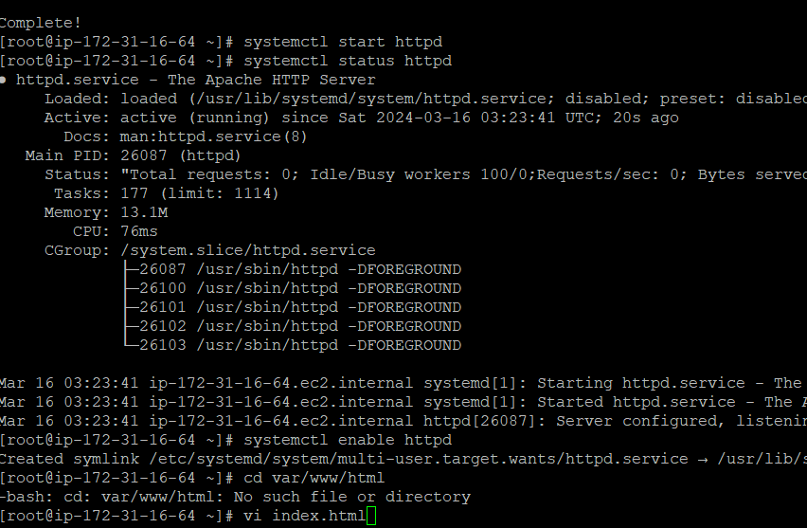



**Step 15- create a file/dir using cd command -**





**Step 16- And then create a vi file-(vi index.html)-**

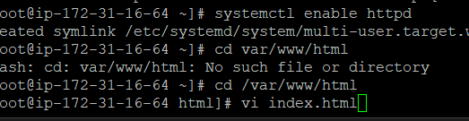

**Step 17- write any given text in a file-( All the best for module end exam)-**

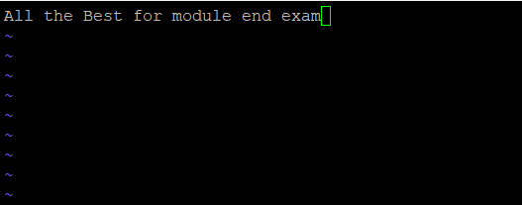

**Step 18- Once again copy the given public ipv4 address-**

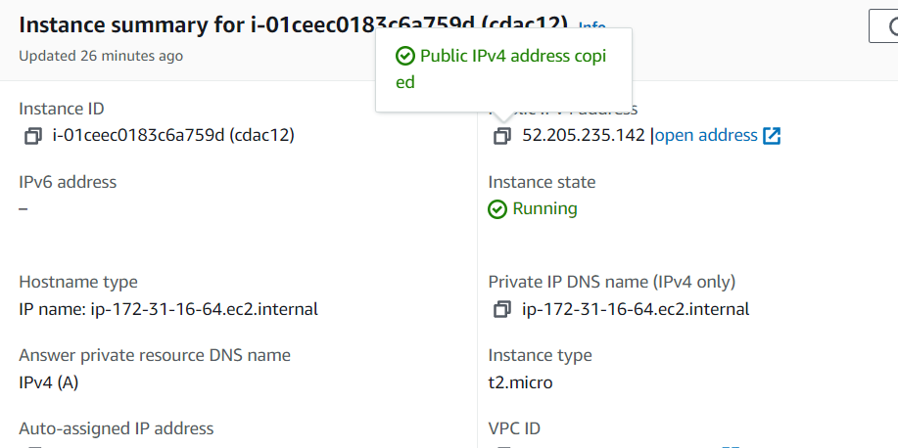



**Codes-**  sudo -i

yum update -y

yum install httpd -y

systemctl start httpd

systemctl status httpd

systemctl enable httpd

cd /var/www/html

vi index.html

cat index.html

**Step 19- Paste the copied ipv4 add on web page and after that terminate the instance-**



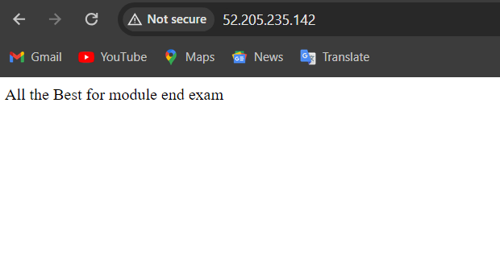



**Q 2- Create S3 bucket-**

**Step 1-Click on Create a bucket-**

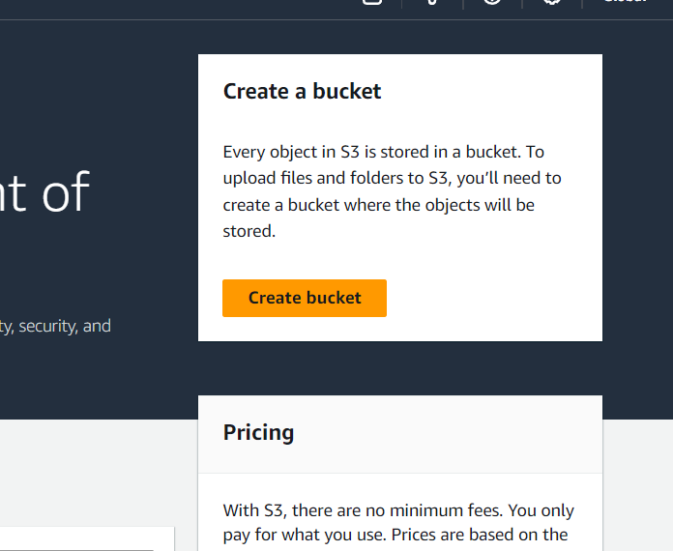



**Step 2- Give a unique name to that bucket-**

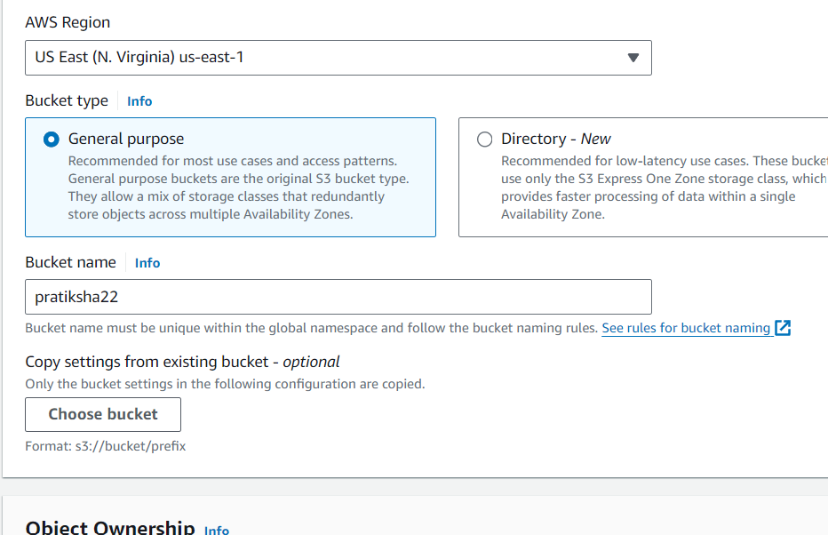



**Step 3- Make enabled the Acls and bucket owner prefer -**

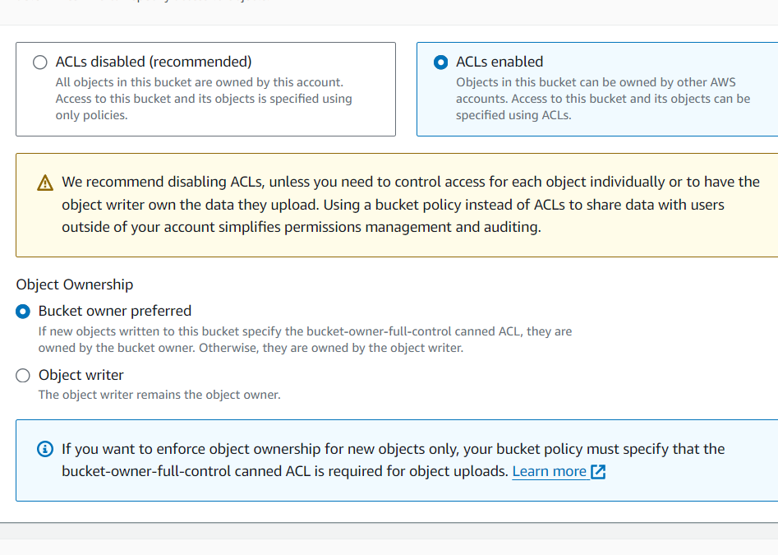



**Step 4- Make a bucket acces public and allow to acknowledge -**



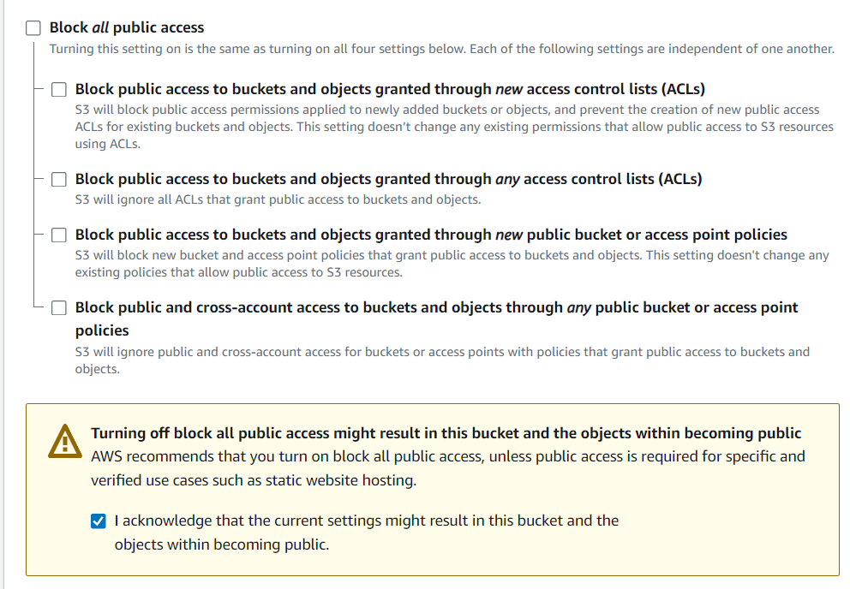



**Step 5- make bucket version Disable-**

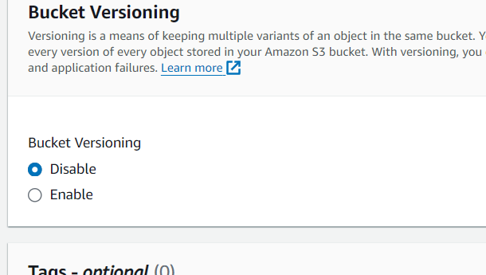



**Step 6- Make a bucket key Disable and click on crate bucket-**

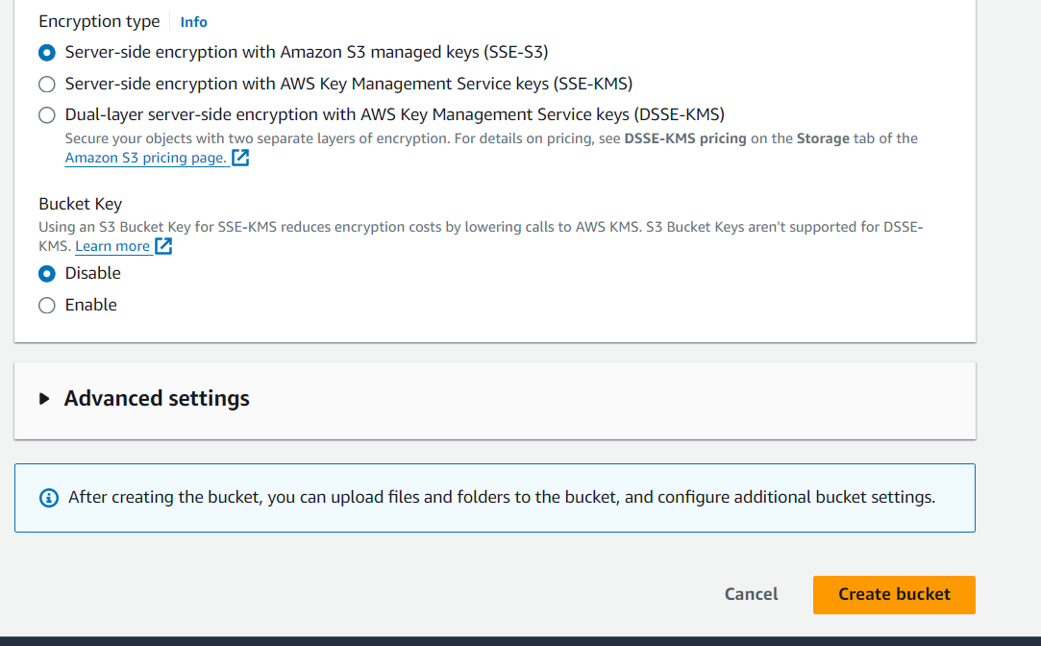



**Step 7- click on created bucket name-**

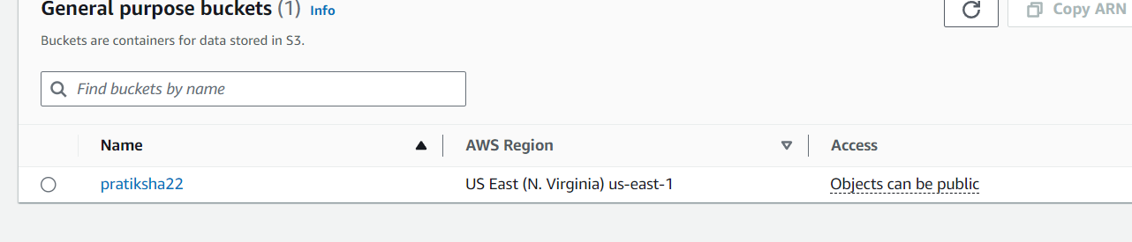



**Step 8-Go on a add files and upload one file then click on upload-**

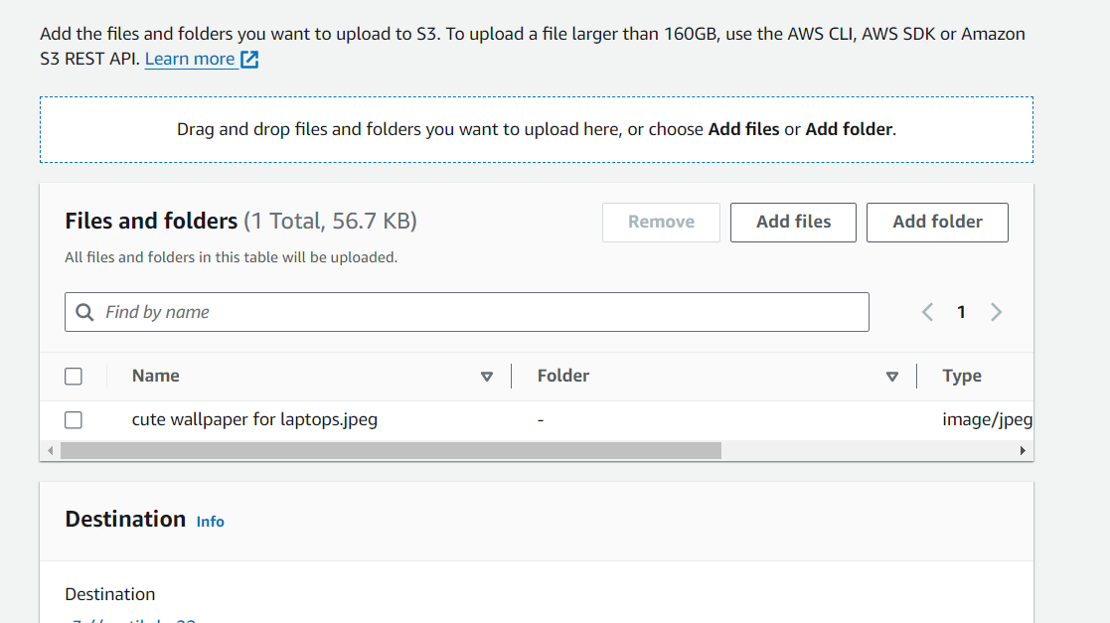



**Step 9- here is the created file shows-**

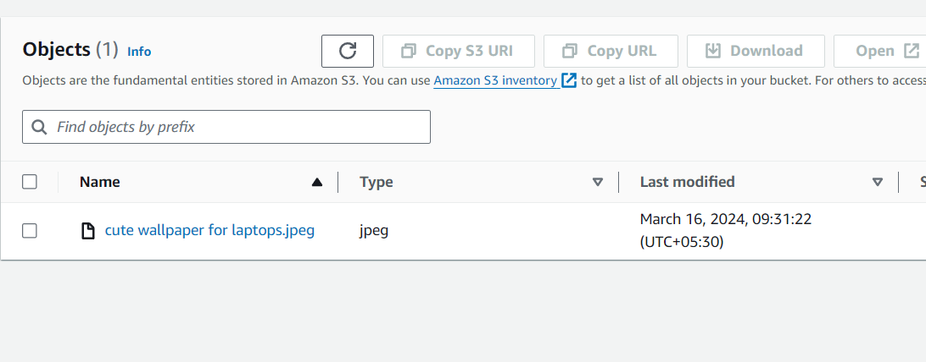



**Step 10 – click on created file and see the properties of it-**

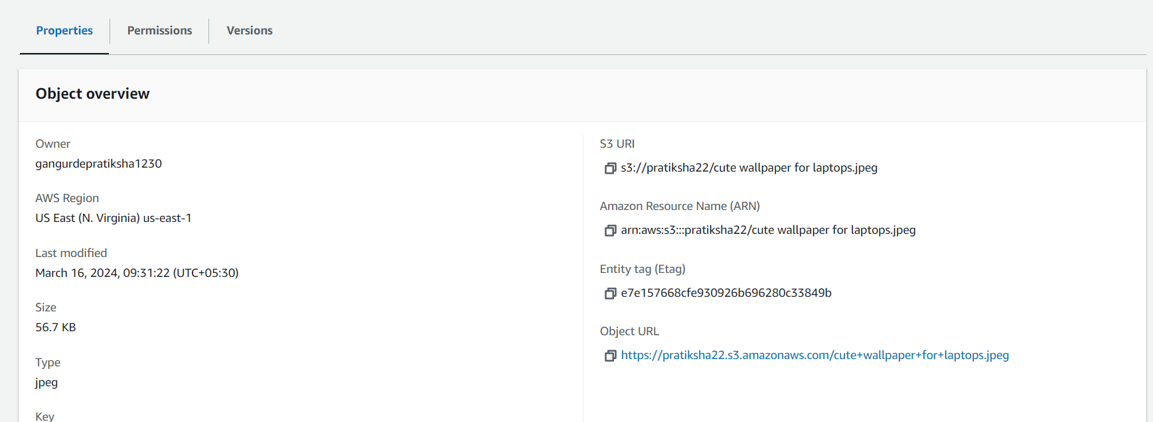



**Step 11- Give read permissions to the file-**

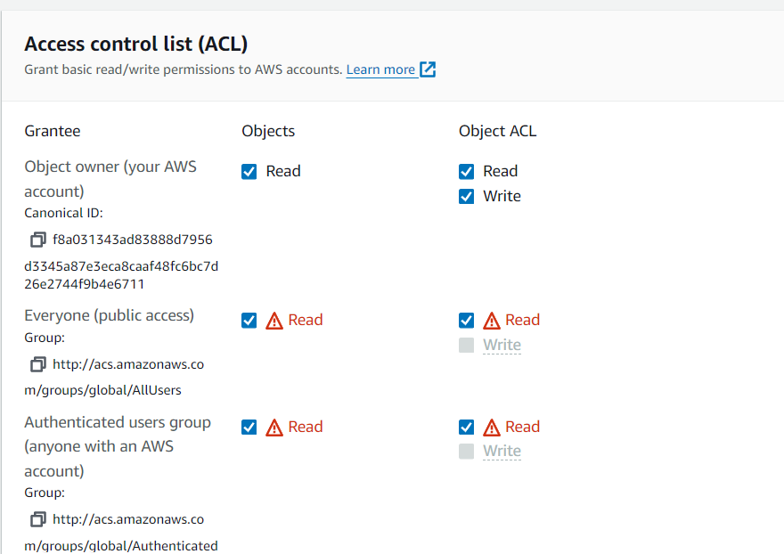

**Step 12- Save the changes-**

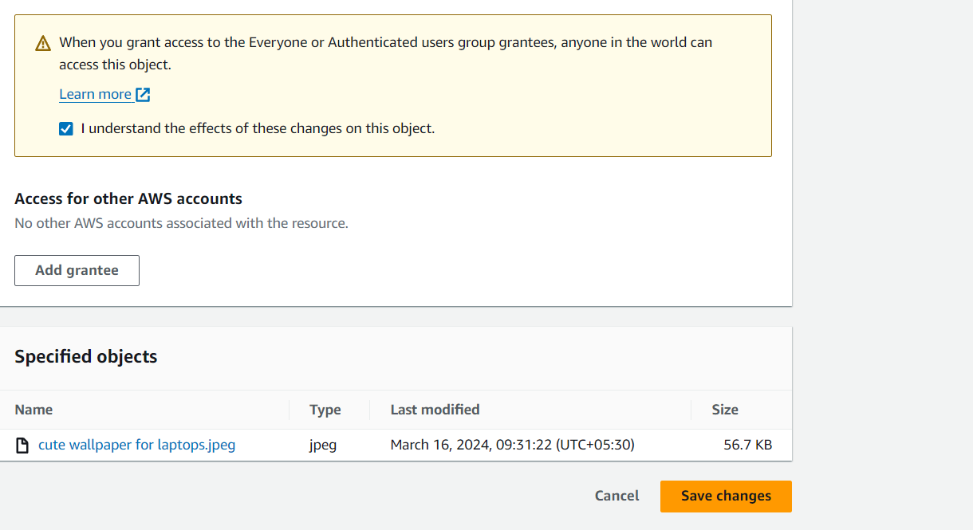



**Step 13- click and open the given url –**

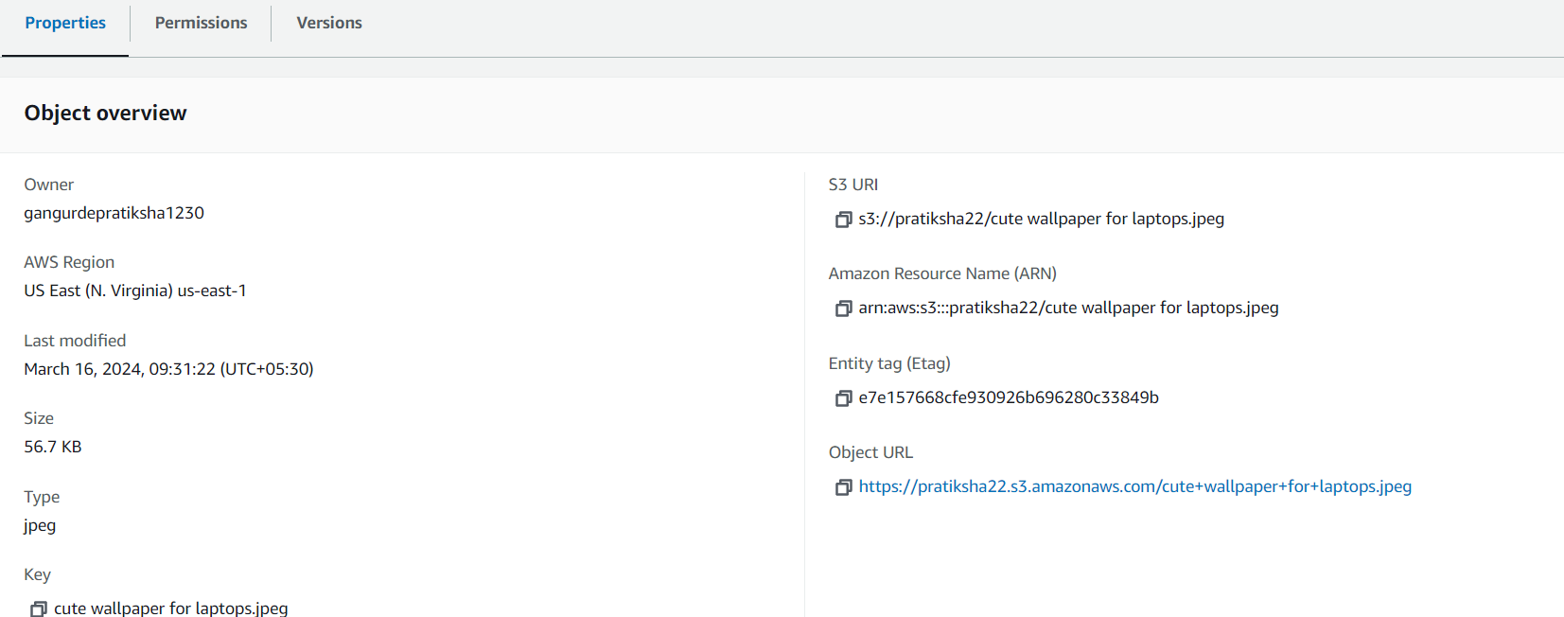



**Step 14- Open this copied url and see the uploaded file-**

**Copied url -**[**https://pratiksha22.s3.amazonaws.com/cute+wallpaper+for+laptops.jpeg**](https://pratiksha22.s3.amazonaws.com/cute+wallpaper+for+laptops.jpeg)



**Step 15- Then empty the given created bucket and then delete it-**



